# Initial Page

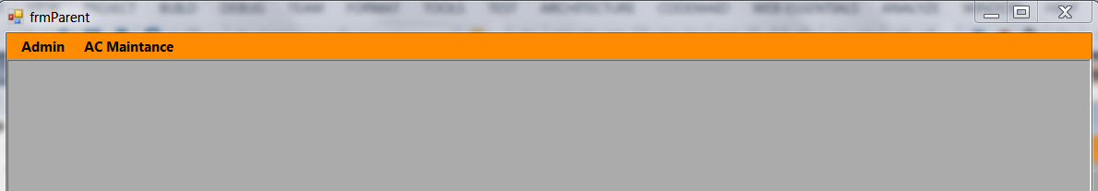

This is first page, which help user to select an option to working on.

Admin – Can manage all Administration of the AC Maintenance system.

* User Setup – First user has to Add user’s which are doing regular AC maintenance.
* Location Setup – Then User has to add frequent location’s which all has AC system.
* AC Type – User has to add main AC type, this will help APM (in future) number of ACs from different company and can plan according.
* AC Master – In this page, user has to enter individual system level entry.

# User Setup

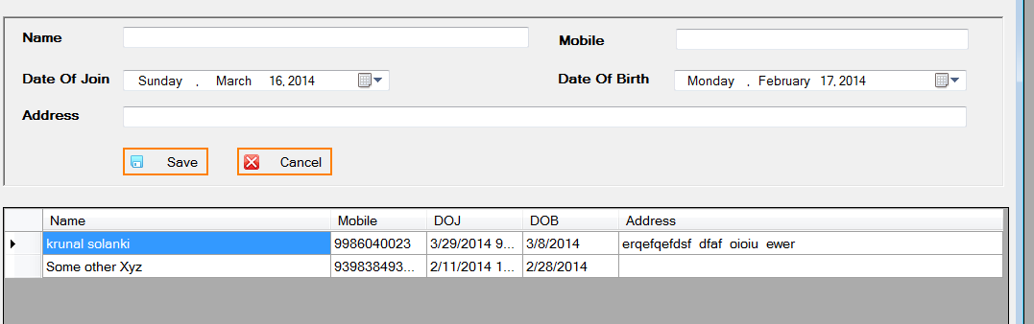

# Location Master

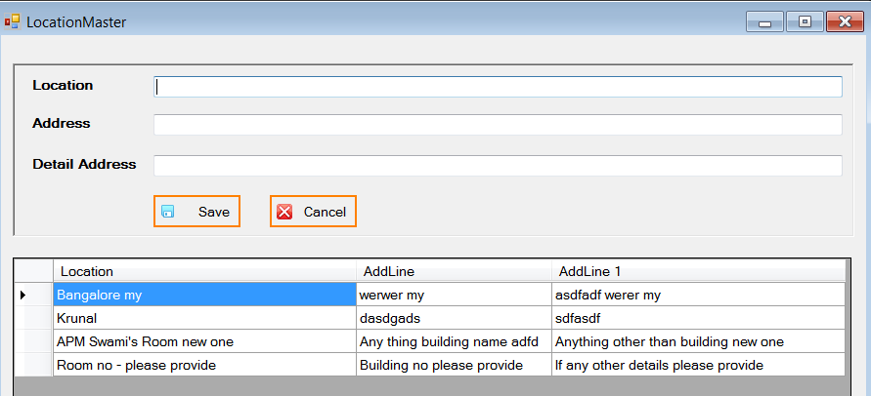

# AC Type

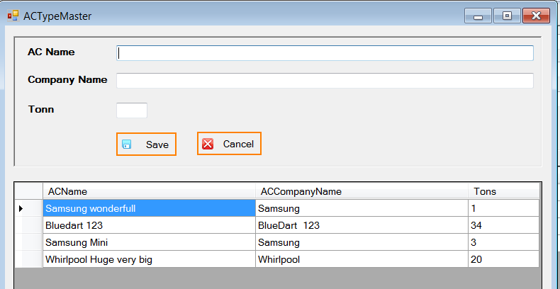

# AC Master

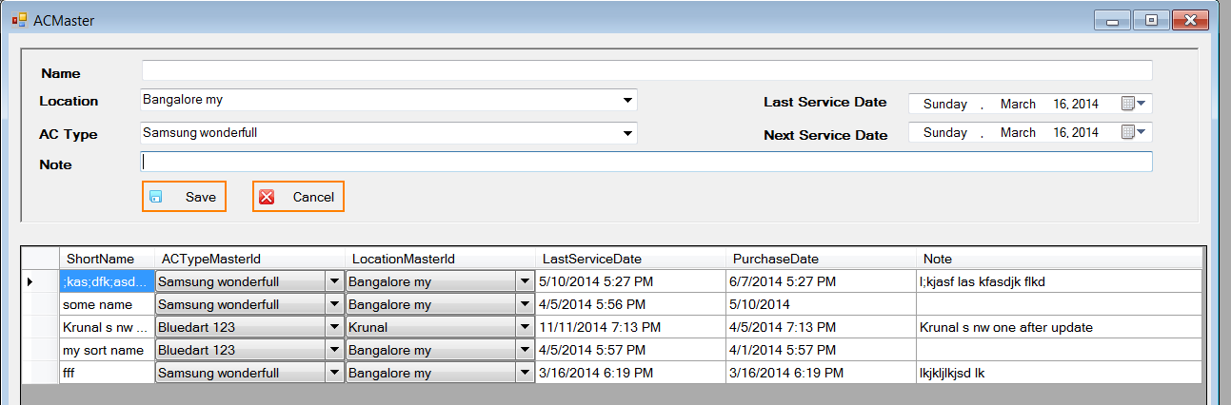

# Main Page Which User has to use daily.

On the click of “AC Maintenance” system will open following page.

The Grid will display as mentioned below, Grey color display already pending maintenance list, and green color indicates for today’s servicing.

User has to click on the record, select person’s name and add note if any.

